Algebra 2

Write the equation in the correct space below (and what makes it correct is the form it is given in): Then identify all the missing pieces of information.
Standard Form:  Vertex (h,k) form:  Intercept form:  Identify all of the key features that exist below. If any do not exist write “Does not exist (D.N.E.) because _______” and justify why.  Y intercept (s):  X intercept (s):  Axis of symmetry :  Asymptote(s):  Domain:  Range:  Minimum(s):  Maximum(s):  End behaviors:  Domain where function is increasing:  Domain where function is decreasing:  Domain where function is positive:  Domain where function is negative:  Vertex:  Stretch or compression factor:  Translation from parent function: | Sketch the PARENT FUNCTION :  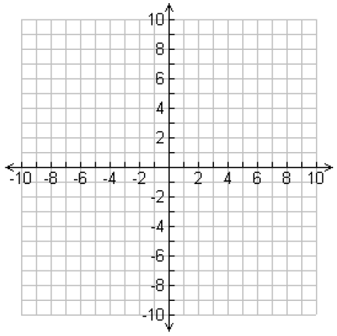  Table of conveniently chosen values:  X Y  Graph the GIVEN FUNCTION:

Standard Form:  Vertex (h,k) form:  Intercept form:  Identify all of the key features that exist below. If any do not exist write “Does not exist (D.N.E.) because _______” and justify why.  Y intercept (s):  X intercept (s):  Axis of symmetry :  Asymptote(s):  Domain:  Range:  Minimum(s):  Maximum(s):  End behaviors:  Domain where function is increasing:  Domain where function is decreasing:  Domain where function is positive:  Domain where function is negative:  Vertex:  Stretch or compression factor:  Translation from parent function: | Sketch the PARENT FUNCTION :  Table of conveniently chosen values:  X Y  Graph the GIVEN FUNCTION:

