Cell Phone Project
Introduction: Cell phones can be expensive. Below, there are four competing companies (Verizon, AT&T, T-Mobile, and Cricket) that offer cell phone plans. Here’s a quick explanation of what goes in to a cell phone plan:
- The original cost of a phone. It may run from $0 (if you get a free upgrade) to $299 if you’re looking for a wonderful, new smartphone. A basic phone is one which is traditionally only used for texting or phone calls. We’ll assume it can take and send pictures. A smartphone is one which accesses the internet, uses apps, etc., and is usually seen in the form of an Android phone or iPhone. The costs of a few common phones are below. Of course, when you go to actually buy a phone (especially a smartphone), you don’t necessarily pick the cheapest phone, but that will be for another day. Assume a basic phone is free with a contract.

- The monthly cost of a phone. Most companies require you to pay a monthly fee for a basic phone and a slightly higher one for a smartphone. You are usually locked in to either a one-year contract or a two-year contract.

- The data plan for a phone. Data is charged for anything besides texts and phone calls that one makes on a cellular network. (There are no charges if your phone is hooked up to a wireless network.) These data charges come from using YouTube or most apps that connect the internet, streaming music, browsing the internet, emails, and GPS features. You pay for a certain amount of data each month. If you go over that limit, your account is charged fairly heavy penalties. Some companies let multiple phones on the same account share a data plan (for example, three phones might share a 2 gigabyte plan), while others require each phone to buy their own data plan. For a person who is always on a wireless network, or doesn’t use most of the features of a smartphone, 1 GB (gigabyte) of data is plenty. Others may need 2 GB or more.
Project: In your group of four, design a poster that explains each of the scenarios below. Each person’s handwriting should be represented equally. You must find a way to represent some of the data graphically.
- Mr. and Mrs. Waddell needs a new cell phone plan. Find the cost per month and per year for 3, 4 and 5 smartphones (we have extended family on our plan and need to decide if we want them to remain on there.)
- Graphically show the costs over time (per month and per year) and make sure the full cost is communicated.
- Mrs. Waddell isn’t very good at math, so you need to clearly communicate your decisions.

Verizon and AT&T (yes they were the same cost) Phones and Costs
http://www.verizonwireless.com/wcms/consumer/shop/shop-data-plans/more-everything.html
http://www.att.com/shop/wireless/plans/mobileshare.html
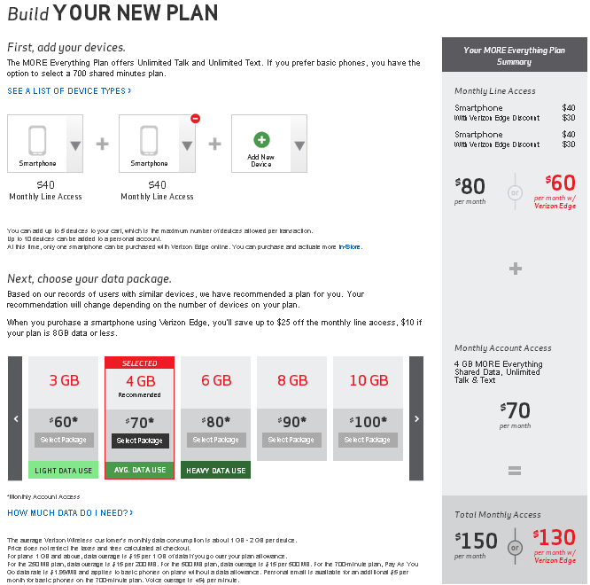

Net10 - http://sale.net10wireless.com/backtoschool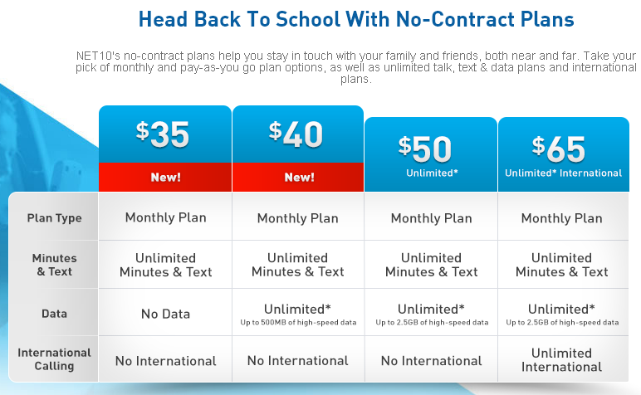
T-Mobile - http://www.t-mobile.com/cell-phone-plans/family.html
