The lesson: Solving equations
Using the “game” introduced in this video: http://www.youtube.com/watch?v=seUU2bZtfgM
Only use the first 6 minutes of this video and stop.

Then, each group will get the following handout and play the “game” to make these numbers equal to zero or explain why they cannot make these numbers equal to zero. One difference between the video and the handout is the allowance for fractional exponents.

After each group has successfully reduced each value to zero, showing and explaining all the steps, move to the literal equation handout.

Make sure you connect the skills of making the numbers equal to zero with the skills of solving literal equations.

Your task is to make the following values equal to zero and explain fully each step. If you cannot reduce the values to zero explain fully why you feel it cannot be done.

- 234 and -398
- $\frac{12}{17}$ and $\frac{18}{12}$
- $\sqrt{18}-14$
- $\sqrt{8}+\sqrt{5}$
- $\sqrt[3]{12}$
- $\sqrt{3^{2}+5^{2}}$
- $8^{3}$
- $\frac{5^{2}-4}{2}$
- $\frac{\sqrt[3]{4^{2}+6}}{2}$
- ${(\sqrt{2}+\sqrt{5})}^{2}$
On a separate sheet of paper solve each of the following literal equations and fully explain each step you make in the process.

- solve for a
- 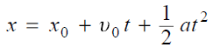solve for a
- 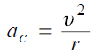 solve for v
- 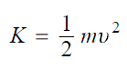solve for m
- 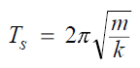 solve for m
- sovle for k
- 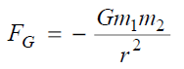solve for r

