Cell Phone Project
Here’s a quick explanation of what goes in to a cell phone plan:
- The original cost of a phone. It may run from $0 (if you get a free upgrade) to $299 if you’re looking for a wonderful, new smartphone. A basic phone is one which is traditionally only used for texting or phone calls. We’ll assume it can take and send pictures. A smartphone is one which accesses the internet, uses apps, etc., and is usually seen in the form of an Android phone or iPhone. The costs of a few common phones are below. Of course, when you go to actually buy a phone (especially a smartphone), you don’t necessarily pick the cheapest phone, but that will be for another day. Assume a basic phone is free with a contract.

- The monthly cost of a phone. Most companies require you to pay a monthly fee for a basic phone and a slightly higher one for a smartphone. You are usually locked in to either a one-year contract or a two-year contract.

- The data plan for a phone. Data is charged for anything besides texts and phone calls that one makes on a cellular network. (There are no charges if your phone is hooked up to a wireless network.) These data charges come from using YouTube or most apps that connect the internet, streaming music, browsing the internet, emails, and GPS features. You pay for a certain amount of data each month. If you go over that limit, your account is charged fairly heavy penalties. Some companies let multiple phones on the same account share a data plan (for example, three phones might share a 2 gigabyte plan), while others require each phone to buy their own data plan. For a person who is always on a wireless network, or doesn’t use most of the features of a smartphone, 1 GB (gigabyte) of data is plenty. Others may need 2 GB or more.

This information is for the teacher, or a learner who needs the information, do not photocopy and give to groups.
Verizon Phones and Costs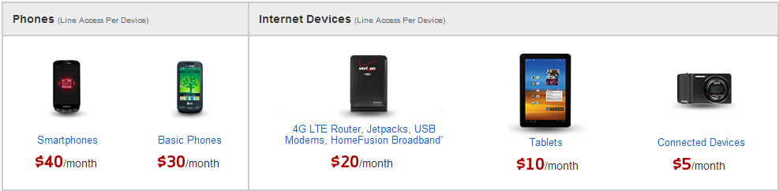
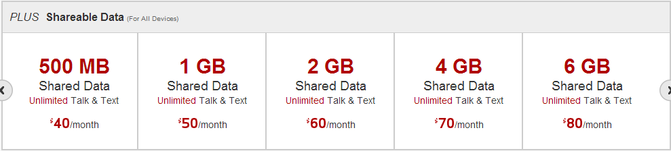
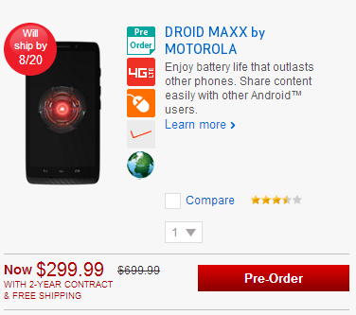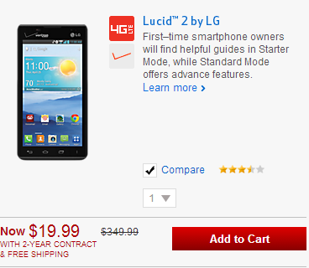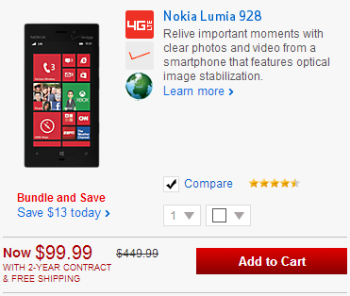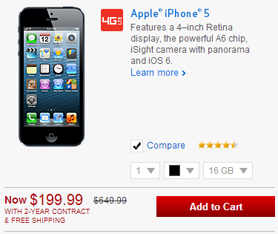
AT&T Phones and Costs
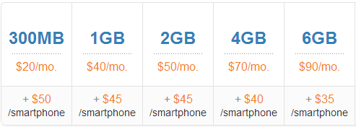
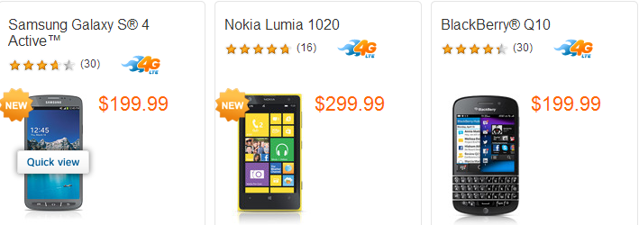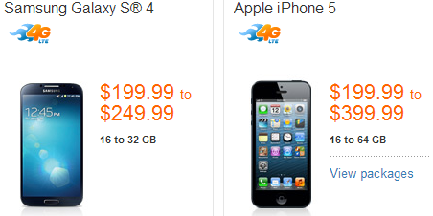

T-Mobile Phones & Plans (Phone price per month included underneath each phone)
- 1 Phone  - 500 MB at $50/month  - 2 GB at $60/month  - Unlimited data at $70/month | - 3 Phones  - 500 MB at $90/month  - 2 GB at $100/month  - Unlimited data at $100/month
- 2 Phones  - 500 MB at $80/month  - 2 GB at $90/month  - Unlimited data at $100/month | - 4 Phones  - 500 MB at $100/month  - 2 GB at $110/month  - Unlimited data at $100/month

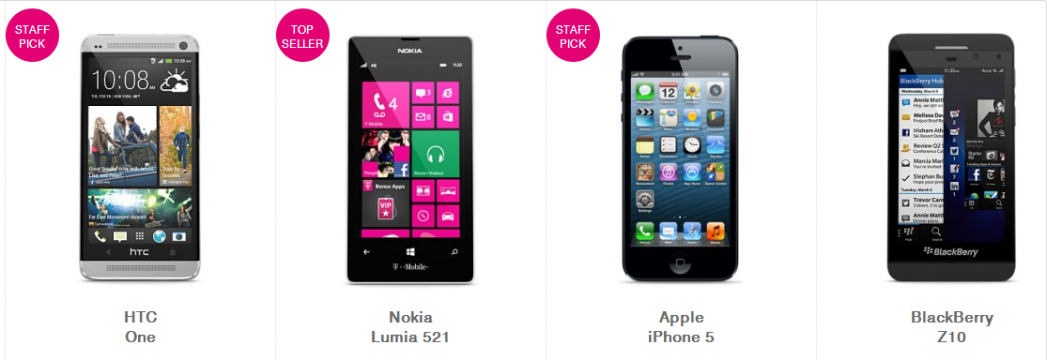
Cricket Phones and Plans (no phone price per month)
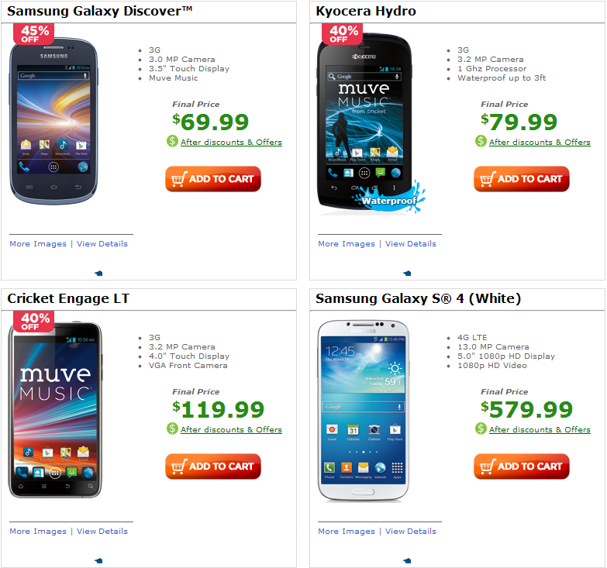
- Basic Phone
  - $35/month
- Smart Phone
  - 2.50 GB for $50/month
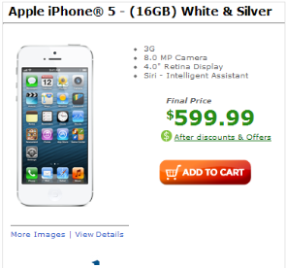
  - 5.00 GB for $60/month
  - 10 GB for $70/month

I need new phones for my house, and we are currently not on contract so we can switch to any company.
I need 2 smartphones and a plan to go with them.
Your task: In your groups, create a poster that lays out the 2 year cost of my 2 new phones and plan. Each person’s handwriting must be represented equally on the poster for everyone to receive full credit. Decide which plan I should get, and explain why clearly enough that my non-mathy significant other will understand. Graphical depictions of the costs would be helpful.

